REQUEST FOR GRANT
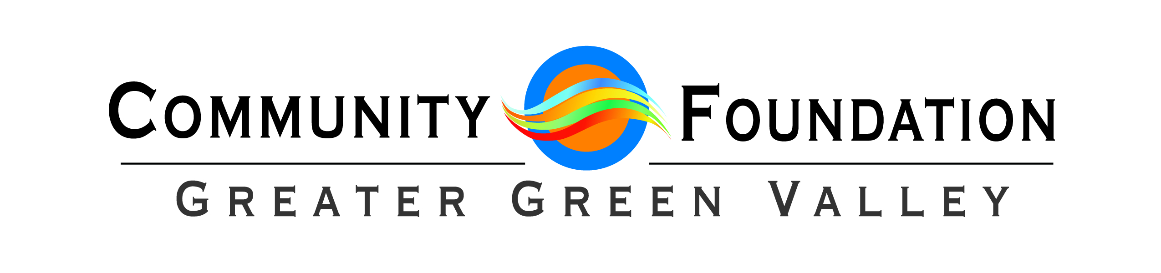

To receive a grant from the Community Foundation, the agency must be classified as a 501(c)3 not-for-profit agency by the Internal Revenue Service

Requests for Grants must be emailed to exd@ggvcf.org
Deadline is April 1, 2024
Grant Awards will be made prior to June 30th 2024

PLEASE MAKE GRANT REQUEST AMOUNT $5,000 or less

Requested Grant Award Amount:

Not For Profit Organization:

Mailing address:

Contact Person:

Telephone:

Email:

Website:

- Please include a copy of the following:
- Latest reviewed/audited financial statements with notes and/or a year-end profit and loss report and balance sheet. Please DO NOT submit IRS Form 990.
- Agency Budget
- Send this completed application including personnel table accompanied by financials and budget information to exd@ggvcf.org by April 1, 2024. DO NOT MAIL OR HAND DELIVER. If you have questions, please contact Michelle at 520.625.4556 or email exd@ggvcf.org.

- Please delineate, in whatever detail necessary, your plans for use of the funds you are requesting from the Greater Green Valley Community Foundation.

Agency Name:
Budget Detail for Personnel Costs for Next Year

Position  Title | Exempt/Full Time/Part Time | Annual  Wage | Fringe  Benefits | Total  Compensation
Executive Director/Manager
List All Additional
Staff Members
Personnel Table

Please explain anything you feel may be necessary:

